RESUME OF

Mr. Hidayat-ullah 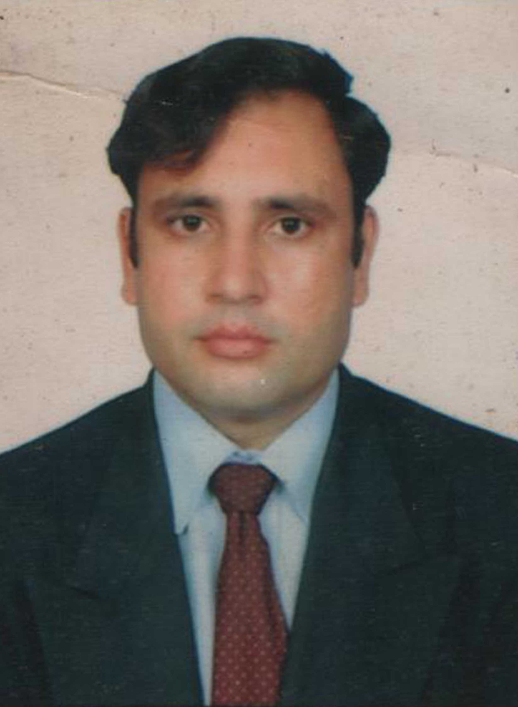
MSc.N, Post RN BSc.N. , RN.
Dispenser. BA, Post Basic Pediatric specialization

Category: Nursing

Objective: to seek a challenging job. I am looking for an opportunity that would help me build up my skills and enjoy my growth. I am confident that I will be able to fulfill my duties in conformity to the requirements of the organization

Personal information:
Father name : Ameen-ur Rahman
Sex : Male
Date of Birth : 20 March 1980
Place of birth : Pakistan
Marital Status : Married
Nationality : Pakistani

NIC No : 15303-3130261-1
Religion : Islam
Professional license number: A35810

Contact Information

Current Address: H# 100, street 6A, sector N4, phase4 hayatabad Peshawar.
Contact Number: 0333-2305667

E-mail address: hidayat.khan10@yahoo.com

EDUCATION AND PROFESSIONAL QUALIFICATION

Academic qualification :
Matriculation 1997
FSc (HSSC) 1999

Bachelor of Arts (BA): From university of Karachi Pakistan.2007

Professional qualification:

MSc Nursing: Liaquat University of medical and health science at college of Nursing JPMC Karachi (2009-2011)

Bachelor of Science in Nursing (Post RN BSN)
From liaquat university of medical and health sciences jamshoro sindh at (College of nursing
Jinnah Post Graduate Medical Center Karachi Pakistan) (2005-2007)

Diploma in Post basic pediatric heath Nursing:
One year specialization diploma in pediatric health
Nursing from Life saving college of Nursing
Affiliated sindh nurses’ examination board
Karachi

Diploma in general Nursing
Three years Diploma in general nursing from
Hamdard university Hospital Rufaida School of nursing M.A Jinnah Road Karachi Pakistan.
(2000-2003)

Dispenser
One year Dispenser Diploma from Sindh Medical Faculty at liaquat National Hospital National stadium road Karachi Pakistan.(1999-2000)

Professional Experience

Lecturer: Presently working as a lecturer in Khyber Medical
University Institute of Nursing Sciences

Principal:
Worked as BSc N program Principal at Life saving college of Nursing Karachi from August; 2010 to 1st Jan 2015.

Nursing instructor:
Worked as Nursing instructor in Life saving college of Nursing Karachi from September 2008 to August 2010
Pediatric specialization coordinator and teacher:
Worked as a post basic pediatric heath nursing specialization program coordinator and teacher at life saving college of Nursing.
Senior Nursing Instructor: worked as senior Nursing instructor at
Ziauddin Medical University college of Nursing from August 2011 to March 2013.
Charge Nurse:
National Institute Of Child Health Karachi Pakistan through public service commission from 3rd February 2006 to February 6, 2014.
Nursing Instructor:
Worked as a Nursing instructor in National institute of child health school of Nursing from 7th feb 2014 to Jan, 2015.
Floor manager:
Worked as a Nursing ward manager in Hamdard university Hospital Karachi Pakistan. In obs/gynae, medical and surgical unit Octobar 2003 to January, 2006.

Extra-curricular activity
- Member of board of study at ziauddin University
- Member of thesis committee at Ziauddin University
- Supervise a number of BSc.N senior elective students as a preceptor.
- Active Member of PNA
- Spock man in annual medical symposium JPMC 2009 and 2010
- World health update conference 26-27 January 2007At Karachi
- Medical, dental and nursing conference
- Certificate of participation International nursing symposium To mark International nurses' day 2007
Topics: positive practice environments
Quality workplaces enhance quality patient care At Aga Khan University Hospital may 12, 2007
- OSCE workshop college of Nursing 2011
- IND 2014 Dow university
- Curriculum and examination workshop SNEB 2014.
Resent achievements:
- Honor form SNEB by holding first position in post basic health Nursing examination
- Best teacher award of 2013 from life saving college of Nursing
- Best teacher award from NICH SON 2014

Computer skill
6 months Diploma in computer from Quraishi computer institute .windows98, windowsxp, internate, MS office, MS Dos, chating

Language: Fluent in English, Urdu and Pashto

Reference
Will be submitted on request

